Bring on the tingles: A study on the effects of ASMR, meditation, and sitting still on stress
Mary R. Nichols
George Mason University
- Introduction
Meditation in the field of psychology is touted as the “end-all, be-all” for psychological and emotional stress management. According to Zen Meditation in Psychotherapy meditation has the capability to “regulate emotions” and “promote deep relaxation and calm” so that “moods, fears, and addictions lose their suffocating grip” (Simpkins & Simpkins, 2012). Moreover, practicing meditation may stabilize brain synapses for patients suffering from Alzheimer’s Disease as well as prevent or delay AD development (Khalsaa, Wesson, 2015) , as well as reduce PTSD symptoms for US military veterans (Seppälä, et. Al, 2014), and help replace feelings of burnout experienced by high school teachers with “a sense of centeredness and a greater ability to accept reality” (Schnaider‐Levi et. Al, 2017), underscoring the broad applicability of meditation practice for wide ranges of individuals as well as for relief from various psychological and physiological sources of suffering. However, a 2014 review of 47 trials with 3,515 participants in mindfulness meditation programs demonstrated only “moderate evidence of improved anxiety…depression…and pain” and “low evidence of improved stress/distress and mental health-related quality of life”, indicating that there may be other treatments available to help combat the effects of stress in contingency with or instead of meditation (Goyal et. al, 2014). Autonomous Sensory Meridian Response (ASMR) is a sensory-based and only recently studied phenomenon in which “individuals experience a tingling, static-like sensation” and is associated with feelings of relaxation and well-being (Barratt & Davis, 2015). The fertile technological grounds of the internet have served as a burgeoning environment for cultivation in interest, production, and sharing of ASMR videos, in which “ASMRtists” produce audiovisual “triggers” like gentle hand movements, whispering, and light tapping sounds such as in videos created by Gentle Whispering, ASMR Glow, and Whispers Red (https://youtu.be/B8jUVci17vE, https://www.youtube.com/watch?v=nViUJWt5vRg&t=486s, https://youtu.be/Km5191gZ9tg). In the ASMR studies that do exist, two large scale online experiments indicate that watching ASMR videos “increased pleasant affect” for people who experienced ASMR and is furthermore associated with “reduced heart rate and increased skin conductance levels” (Lara, Poerio 2018). These results reveal that ASMR is a “reliable and physiologically rooted experience” and therefore may have therapeutic benefits for both psychological and physical health (Lara, Poerio 2018). In the present study, I will determine if ASMR or meditation compared with a control condition (sitting still) produce the greater change in heart rate and blood pressure as physiological indicators of stress over a six week period.
- Methods
In the present study, I controlled for ambiance (room and lighting/noise conditions), time of day (between 2:00-3:00pm), treatment time (20 minutes), number of treatments (14), as well as days of the week to mitigate possible differing stress levels associated with weekdays and weekend days (6 each) (Kim, Lee, Ahn, 2010). The study took place over a six week period. Materials included a heart rate monitor, blood pressure cuff, ambient noise reducing headphones, timer, laptop for ASMR videos, and Google Sheets for recording data. I did not control for exercise, sleep, or caffeine because I did not want to interfere with my daily life activities. I also did not include my original plan to incorporate a stress control prior to the administering of the relaxation technique treatments: I piloted a stressful activity prior to the administration of the relaxation treatments where I tried to complete challenging SAT math problems with a large 7 minute timer while a loud persistent beep blared on the laptop. During the pilot trial my blood pressure reached stage 1 of hypertension which posed a health risk over the six-week period. I could have amended the trial to be less stressful, but the aim of the study was to improve stress levels as opposed to stagnate or aggravate them. In addition, I may have improved performance overtime due to practice effects, which could further confound treatment effects due to increased feelings of confidence from solving mathematical conundrums.
Prior to logging heart rate and blood pressure readings, I sat for one minute and waited for the reading to stabilize prior to recording the initial heart rate. Then I took blood pressure readings three times to control for consistency and recorded the final blood pressure value. If readings were inconsistent, I would take an additional three readings due to potential hypersensitivity of the blood pressure cuff. I then set a timer for twenty minutes. If I was undergoing an ASMR or a guided meditation video, I would conduct a search on YouTube on the laptop and play the video for twenty minutes. I then would take readings of my heart rate and blood pressure numbers after the twenty minutes, following the same protocol for both blood pressure readings and heart rate as prior to the administration of the treatment. For meditation, I included both guided YouTube videos as well as self-guided meditation from my own experience with Dzogchen Buddhism. Because there were only 14 trials associated with each treatment, I did not distinguish between self-guided and guided meditation videos as to avoid making inferences without sufficient data. There were, however, a few weekend days in which I did not undergo the treatments but made up for them by conducting multiple treatments in the corresponding day.
During this time I received a vaccine for the coronavirus and upon receiving the second dose I abstained from administering the mindfulness treatments to avoid possible confounding effects from the vaccine. In addition, there were instances when I could not utilize the designated space for the study and had to undergo the treatment in a different environment. Construction of a building next door also posed disruptions, which I mitigated with noise reducing headphones.

- Results
Results are based off average raw data calculations and Pearson coefficient calculations to identify fit of data. ASMR produced the greatest average change in heart rate (-2.5 bpm, R²=.493), systolic blood pressure change (-7 mm Hg, R²=.161) and diastolic change (-4.36 mm Hg, R²=.218), whereas meditation only decreased heart rate on average by .29 bpm (R²=.004), lessened systolic blood pressure by 3.93 mm Hg (R²=.221) and diastolic by 2.36 mm Hg (R²=.035). Sitting still increased heart rate by .14 bpm (R²=.057), and interestingly decreased systolic by 5.43 mm Hg (R²=.012) (a greater systolic change than meditative treatments), and decreased diastolic by 1.86 mm Hg (R²=.144). The accumulative effects of all three treatments together are based off raw collected data and Pearson coefficient calculations. While the effects of the relaxation techniques aggregately did not decrease initial heart rate readings (R²=.001), the post treatment reading of heart rate decreased over the six-week period, from 64 bpm to 59 bpm (R²=.313). Blood pressure, on the other hand, displayed reductions for initial and post treatment readings for both diastolic and systolic measures. Pre readings for systolic pressure at week 1 averaged at 124/81 (elevated/high blood pressure) and decreased to 112/69 (healthy/normal blood pressure). Post readings also demonstrated significant differences from week 1 to week 6 from an average blood pressure reading of 120/77 (elevated) to 106/68 (healthy/normal). Staggeringly, unlike heart rate readings, the relaxation treatments aggregately accounted for R²=.936 of variability for pre systolic readings and R²=.817 of variability for post systolic readings, as well as R²=.895 for pre diastolic and R²=.817 for post diastolic readings.
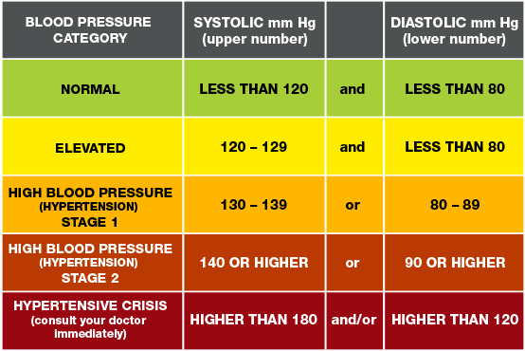
Figure 1 Source: https://www.heart.org/en/health-topics/high-blood-pressure/understanding-blood-pressure-readings

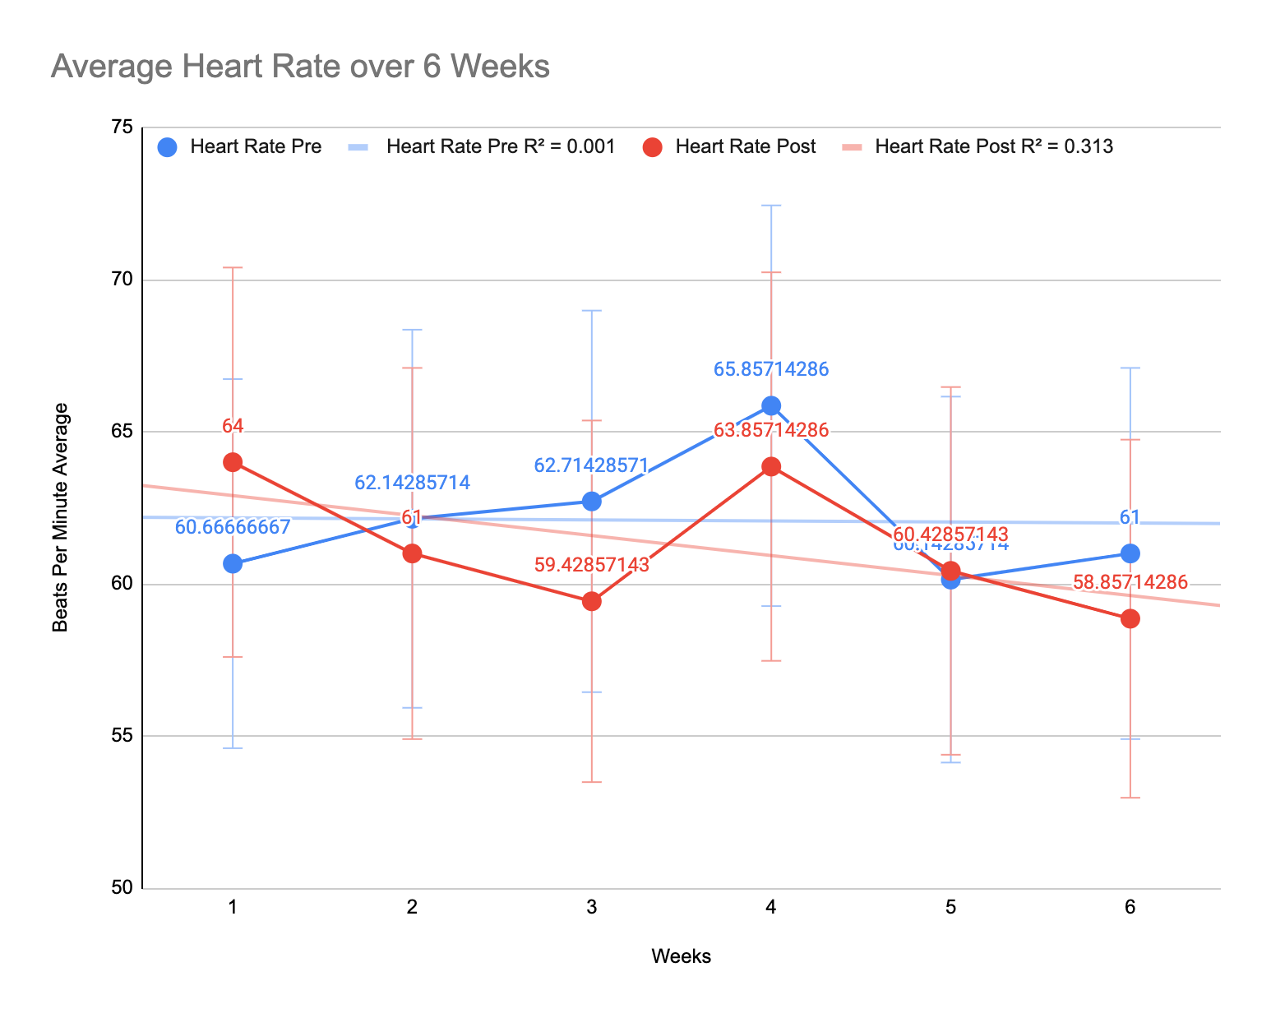
Figure 2

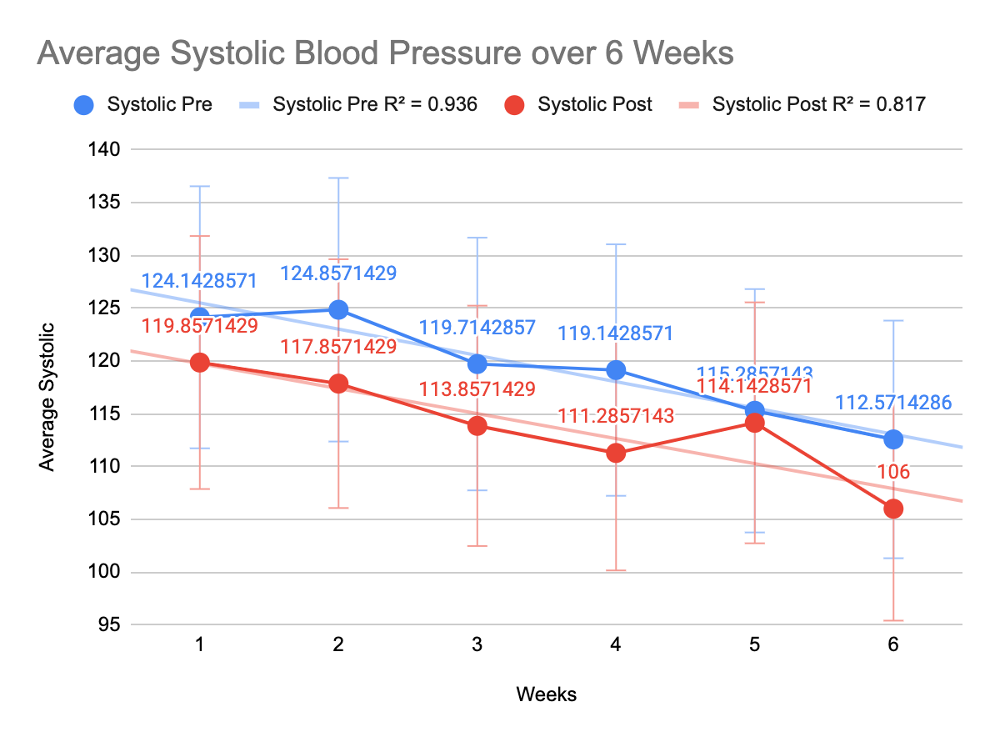
Figure 3

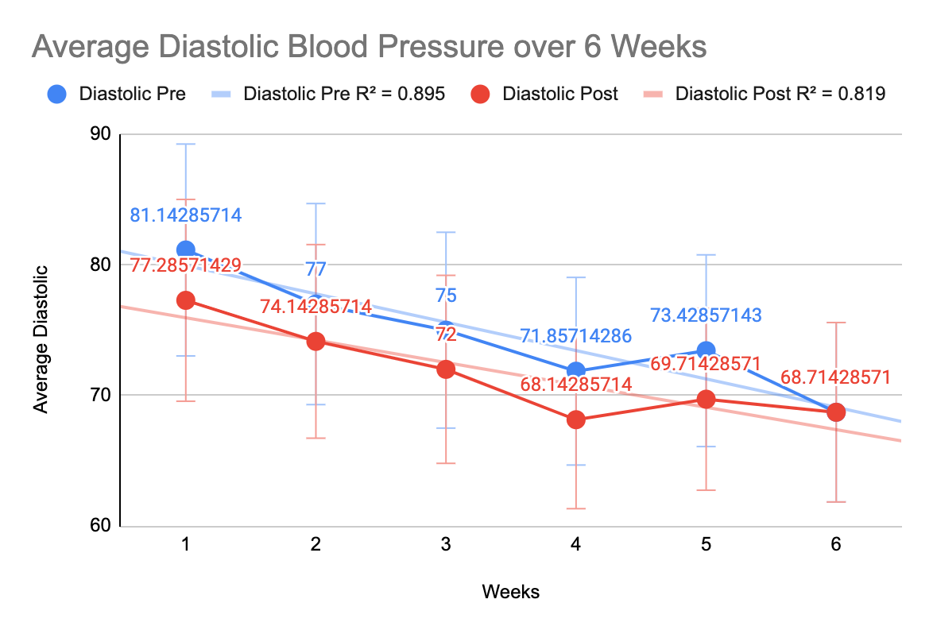
Figure 4

- Discussion
Although ASMR accounted for the greatest amount of variability as well as average changes for heart rate and blood pressure changes, clearly interaction effects were present during the study, obfuscating which treatments or treatment combinations would be most beneficial for combating the effects of stress physically and psychologically. In addition, the Pearson coefficients suggest that the treatments did not explain aggregate changes in heart rate for initial readings and moderately explained changes for post readings, elucidating that other lifestyle changes such as diet or exercise may produce more beneficial changes to heart rate over time. Increasing the longevity of the study and expanding it to include more participants with a wider range of stressors and health markers may yield clearer findings than allocating it to one individual.
However, it is clear that consistent relaxation treatments have the potential to yield tremendous physical and psychological benefits as reflected in the data. Although the pre treatment heart rate remained consistent over the six week period, the post treatment average change suggests that my body’s capacity to physically relax was expanding. Moreover, both blood pressure initial and post readings decreased over time, signifying an aggregate effect on blood pressure for both initial and post treatment readings. These findings may illustrate that the body’s threshold for relaxation is not fixed, but is rather plastic; the body has the ability to learn not only how to enter into a calm state, but rather relax more over time. Therefore, relaxation may not just be a stagnant state, but is a skill.
Moreover, as Goya et. al intimates, meditation may only account for a moderate constituent for relaxation and that other techniques such as ASMR should be explored (2015). In this rapidly developing world of technology, which is paradoxically a virtual factory of anxiety as well as a potential solution for stress relief, the field of human performance must be adaptive to the tools that can enhance human performance and refrain from clinging to fads in favor of ignoring data.

References
Barratt & Davis (2015) Barratt EL, Davis NJ. Autonomous sensory meridian response (ASMR): a flow-like mental state. PeerJ. 2015;3:e851. doi: 10.7717/peerj.851

Goyal, M., Singh, S., Sibinga, E., Gould, N., Rowland-Seymour, A., Sharma, R., Berger, Z., Sleicher, D., Maron, D., Shihab, H., Ranasinghe, P., Linn, S., Saha, S., Bass, E., & Haythornthwaite, J. (2014). Meditation Programs for Psychological Stress and Well-being: A Systematic Review and Meta-analysis. JAMA Internal Medicine, 174(3), 357–368. https://doi.org/10.1001/jamainternmed.2013.13018

Khalsa, D. (2015). Stress, Meditation, and Alzheimer’s Disease Prevention: Where The Evidence Stands. Journal of Alzheimer’s Disease, 48(1), 1–12. https://doi.org/10.3233/JAD-142766

Kim, M. S., Lee, Y. J., & Ahn, R. S. (2010). Day-to-day differences in cortisol levels and molar cortisol-to-DHEA ratios among working individuals. Yonsei medical journal, 51(2), 212–218. https://doi.org/10.3349/ymj.2010.51.2.212

Schnaider‐Levi, L., Mitnik, I., Zafrani, K., Goldman, Z., & Lev‐Ari, S. (2017). Inquiry‐Based Stress Reduction Meditation Technique for Teacher Burnout:A Qualitative Study. Mind, Brain and Education, 11(2), 75–84. https://doi.org/10.1111/mbe.12137

Seppälä, E., Nitschke, J., Tudorascu, D., Hayes, A., Goldstein, M., Nguyen, D., Perlman, D., & Davidson, R. (2014). Breathing‐Based Meditation Decreases Posttraumatic Stress Disorder Symptoms in U.S. Military Veterans: A Randomized Controlled Longitudinal Study. Journal of Traumatic Stress, 27(4), 397–405. https://doi.org/10.1002/jts.21936

Simpkins, C., & Simpkins, A. (2012). Zen meditation in psychotherapy : techniques for clinical practice . Wiley.

